
4441 Buckeystown Pike, Suite A, Frederick, MD 21704-7507 Phone: 240-436-4900 Fax: 240-436-4899

Preliminary Report of Laboratory Assessment

Name of Laboratory: | University of Arkansas
Laboratory Location: | Fayetteville, Arkansas
Assessment Number: | 632R

It is intended that the final on-site assessment report will reflect the findings noted in this preliminary report; however, in preparation of the final report, a thorough review of the work sheets and test standards may uncover additional findings or indicate that a finding noted in the preliminary report is inappropriate.

Laboratory Contact E-mail: | sgwill@uark.edu | Laboratory Contact Name: | Dr. Stacy Williams, P.E., Ph.D
Assessor: | Ryan LaQuay | Date: | December 10, 2013

REPORT ON MATERIALS TESTING LABORATORY ASSESSMENT:

University of Arkansas
700 Research Center Boulevard
Fayetteville, Arkansas 72701

AMRL Assessor: Ryan LaQuay
Assessment Number: 632R
Date of Assessment: December 10, 2013

GENERAL INFORMATION

The assessment covered by this report included a review of the Hot Mix Asphalt, Soil and Aggregate testing facilities. In addition, an examination of the laboratory’s Quality System based on the criteria specified in AASHTO Standard Practice R18 was performed.

This report contains a “Summary of Findings” table for each of the areas examined during the assessment. A “Findings” section follows each “Summary of Findings” table, which describes deviations from specification requirements (nonconformities), states specific observations, and notes other relevant matters.

AMRL applied the most recent versions of AASHTO, ASTM or other governing standards available at the time of the assessment. At the conclusion of the assessment, the assessor presented a preliminary report summarizing the findings to the laboratory staff. The findings presented in this final report may vary slightly from those included in the preliminary report.

ASSESSMENT FINDINGS

Findings in this report are classified as nonconformities, observations, or informational. Definitions for these terms are provided below.

- Nonconformities: A finding that indicates policy or practice contrary to the requirements of applicable standards or documented quality system procedures.
- Observations: (1) A technically-related finding that is not likely to affect the ability of the laboratory to produce valid and accurate test results; (2) A minor failure in some part of the organization’s quality management system, such as a single observed lapse in following one procedure or the lack of information required on a record. NOTE: Observations are required to be addressed internally by the laboratory. Repeat observations can result in a nonconformity.
- Informational: (1) Specific technical information provided for informational purposes only. (2) Information about pending or anticipated changes to test standards, AASHTO R 18, and the AAP Procedures Manual.

RESOLUTION OF FINDINGS

Resolving Nonconformities
Laboratories seeking AASHTO accreditation or wishing to maintain their accreditation status must resolve all findings labeled as “Nonconformities” within 90 calendar days of the issuance of this final report. The responses must include a description of the corrective action taken and substantiating evidence, such as records; copies of newly prepared or revised documents; equipment packing slips; calibration, standardization, and check records; and photographs. A root cause analysis may be required to resolve nonconformities. Repeat nonconformities will require more extensive responses.

RESOLUTION OF FINDINGS (CONT’D)

Corrective Action of Nonconformities and Root Cause Analysis
Resolving nonconformities requires corrective action as follows: (1) Take immediate interim action to isolate the effects of the problem, (2) Take immediate action to correct the problem, (3) Investigate the root cause of the problem, if needed, and (4) Implement permanent corrective action to prevent recurrence of the problem.

Note: Root cause analysis can be the most difficult and most important part of the corrective action process. Root cause analysis attempts to determine why the nonconformity occurred in the first place. Its focus is “Why did this happen?” Potential causes could include: insufficient staff training and skills; vague policies and procedures; inadequate frequencies for calibrating or checking equipment; and human error.

If more than 90 calendar days are needed to resolve a nonconformity, your laboratory must provide AMRL with a written plan for resolving the nonconformity including an estimated completion date and any evidence of action taken, such as equipment purchase orders. Plans for future resolution of nonconformities will be reviewed and may result in accreditation being granted, denied, suspended, or revoked. If your laboratory does not resolve a nonconformity within 180 calendar days of the issuance of the final report, and desires to maintain its accreditation, an additional on-site assessment may be required.

Resolving Observations
Laboratories are not required to provide written documentation to AMRL describing action taken to address findings identified as “Observations.” The laboratory should, however, take necessary corrective action to address the observation to prevent possible recurrence. Repeat observations may result in nonconformities.

Resolving Informational Findings
Laboratories are not required to provide written documentation to AMRL describing action taken to address findings identified as “Informational.”

For a complete explanation of the AASHTO Accreditation Program policies and procedures, please see the Procedures Manual located at www.amrl.net.

SUBMITTING RESPONSES TO FINDINGS

To respond to nonconformities contained in this report, log in to www.amrl.net using your laboratory’s credentials and select the “My Tab” option at the top of the page. Select the “View My Accreditation Events” link at the top of the left-hand column and select the Accreditation Event that corresponds to the report number as issued in this report. Please follow the instructions included on this web page to submit responses to the nonconformities.

CONTACT INFORMATION

For general questions about the assessment program, please use the following contact information:

Contact Information
AMRL  4441 Buckeystown Pike  Suite A  Frederick, MD 21704-7507 | Fax:  240-436-4899  Phone:  240-436-4900 | Email:  aap@amrl.net

Laboratories Seeking AASHTO Accreditation
If your laboratory is not accredited by AASHTO, but desires AASHTO accreditation, your laboratory may obtain accreditation based on an application submitted subsequent to an on-site assessment provided: (1) the on-site assessment includes an AASHTO R 18 quality management system review of the applicable field(s), (2) the application is submitted within 90 calendar days of the date of issuance of this final report, and (3) nonconformities are resolved as described previously.

SUMMARY OF FINDINGS
GENERAL APPARATUS
The table below indicates the Standards observed and discussed during the assessment, and the conformance of the laboratory to specified requirements. A "- - - - - - -" in the Status columns indicates that this item was not included.
ITEM EVALUATED | STATUS
Mechanical Sieving Apparatus | Satisfactory
Ovens | See Finding (a)
Literature | Satisfactory
Sample Reducing Apparatus | Satisfactory
Sieves | Satisfactory
Thermometers | Satisfactory
General Purpose Balances | Satisfactory
FINDINGS
(a) Ovens
Nonconformity
The temperature of the QL-make oven (Serial No. 9602246) presented was not maintained at 110 ± 5°C (230 ± 9°F). The temperature ranged from 99.8 to 111.8°C.

SUMMARY OF FINDINGS (HOT MIX ASPHALT)
The table below indicates the Standard test methods observed and discussed during the assessment, and the conformance of the laboratory to specified equipment and procedural requirements. A " - - - - - - -" in the Status columns indicates that the laboratory elected not to include this item as part of the assessment.
Test Method | Designation | AASHTO/Other | ASTM
Reducing Samples of Hot-Mix Asphalt | R47 / ----- | Satisfactory | -----
Mechanical Analysis of HMA | T30 / D5444 | Satisfactory | -----
Bulk Specific Gravity of Compacted Hot Mix Asphalt | T166 / D2726 | Satisfactory | -----
Maximum Specific Gravity of Hot Mix Asphalt Paving Mixtures | T209 / D2041 | Satisfactory | -----
Percent Air Voids in Bituminous Paving Mixtures | T269 / D3203 | Satisfactory | -----
Asphalt Content of Asphalt Mixtures (Nuclear Method) | T287 / D4125 | Satisfactory | -----
Asphalt Content by Ignition Method | T308 / D6307 | Satisfactory | -----
Hot Mix Asphalt Superpave Gyratory Compactor | T312 / D6925 | Satisfactory | -----
Moisture Content of HMA by Oven | T329 / ----- | Satisfactory | -----
Bulk Specific Gravity Using Vacuum Sealing Method | T331 / D6752 | Satisfactory | -----
FINDINGS
None.

SUMMARY OF FINDINGS (SOIL)
The table below indicates the Standard test methods observed and discussed during the assessment, and the conformance of the laboratory to specified equipment and procedural requirements. A " - - - - - - -" in the Status columns indicates that the laboratory elected not to include this item as part of the assessment.
Test Method | Designation | AASHTO/Other | ASTM
Dry Preparation of Samples | R58 / D421 | Satisfactory | -----
Liquid Limit of Soils (Atterberg Limits) | T89 / D4318 | Satisfactory | -----
Plastic Limit of Soils (Atterberg Limits) | T90 / D4318 | Satisfactory | -----
Moisture-Density (Proctor) of Soils, Standard Effort | T99 / D698 | Satisfactory | -----
Moisture-Density (Proctor) of Soils, Modified Effort | T180 / D1557 | Satisfactory | -----
Moisture Content of Soils | T265 / D2216 | Satisfactory | -----
Nuclear Density and Moisture Gauge for Soil | T310 / D6938 | Satisfactory | -----
FINDINGS
None.

SUMMARY OF FINDINGS (AGGREGATE)
The table below indicates the Standard test methods observed and discussed during the assessment, and the conformance of the laboratory to specified equipment and procedural requirements. A " - - - - - - -" in the Status columns indicates that the laboratory elected not to include this item as part of the assessment.
Test Method | Designation | AASHTO/Other | ASTM
Sampling Aggregate | T2 / D75 | Satisfactory | -----
Material Finer Than 75-µm (No. 200) Sieve | T11 / C117 | Satisfactory | Satisfactory
Organic Impurities in Sands | T21 / C40 | Satisfactory | Satisfactory
Sieve Analysis of Aggregates | T27 / C136 | Satisfactory | Satisfactory
Fine Aggregate Specific Gravity and Absorption | T84 / C128 | Satisfactory | Satisfactory
Coarse Aggregate Specific Gravity and Absorption | T85 / C127 | Satisfactory | Satisfactory
Reducing Samples of Aggregate to Test Size | T248 / C702 | Satisfactory | -----
Moisture Content of Aggregate by Oven Drying | T255 / C566 | Satisfactory | -----
Uncompacted Void Content of Fine Aggregate | T304 / C1252 | Satisfactory | -----
FINDINGS
None.

SUMMARY OF FINDINGS
QUALITY SYSTEM CRITERIA
The table below indicates the Standards observed and discussed during the assessment, and the conformance of the laboratory to specified requirements. A "- - - - - - -" in the Status columns indicates that this item was not included.
Standard Practice R18 Management Requirements
ITEM EVALUATED | STATUS
Quality Management System | Satisfactory
Document Control | Satisfactory
Organization | Satisfactory
Staff | Satisfactory
Technician Training and Evaluation | Satisfactory
Internal Audits | Satisfactory
Corrective Action | Satisfactory
Records Retention | Satisfactory
Standard Practice R18 Technical Requirements
ITEM EVALUATED | STATUS
Equipment | Satisfactory
Equipment Calibration, Standardization, Check, and Maintenance Records | Satisfactory
Sample Management | Satisfactory
Test Records and Reports | Satisfactory
Subcontracting | Satisfactory
Assuring the Quality of Results | Satisfactory
Additional Quality System Evaluations
ITEM EVALUATED | STATUS
ASTM C1077 - Standard Practice for Laboratories Testing Concrete and Concrete Aggregates | See Finding (a)
ASTM D3666 - Standard Specification for Agencies Testing and Inspecting Road and Paving Materials | -----
ASTM D3740 - Standard Practice for Agencies Testing Soil and Rock | -----
ASTM E329 - Standard Specification for Agencies Testing Materials Used in Construction | -----
FINDINGS
(a) ASTM C1077 - Standard Practice for Laboratories Testing Concrete and Concrete Aggregates
Informational
Any findings are incorporated in the preceding AASHTO R18 quality system findings. In addition, laboratory personnel qualifications were not reviewed during the on-site assessment. Personnel qualifications are evaluated for conformance to applicable quality system criteria prior to obtaining AASHTO accreditation and annually for all AASHTO accredited laboratories.

YOUR FEEDBACK IS IMPORTANT!

AMRL is always looking for ways to improve, so we invite you to evaluate your assessment. To submit your comments, go to www.amrl.net, pull down the “About Us” menu, and select the option for “Submit Feedback”.

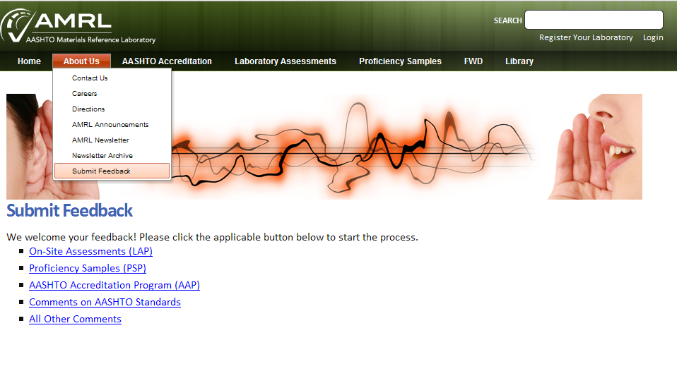

Thank you, and we appreciate your feedback!

